Types of Interrupts:
External Interrupt:
- Used by CPU to interact with I/O device.
- This improves system performance by allowing the CPU to execute instructions, instead of just waiting for the I/O device, while still performing the required data transfers.
- Internal Interrupt:
- Occurs entirely within CPU, I/O devices play no role in these interrupts.
- For example, a timer built into the CPU may generate an interrupt at a pre-determined interval.
- Software Interrupt:
- Generated by the program itself.
- It itself is like a subroutine. Eg: HLT
When we give HLT, it calls a predefined subroutine for it, which stops the program we are using.
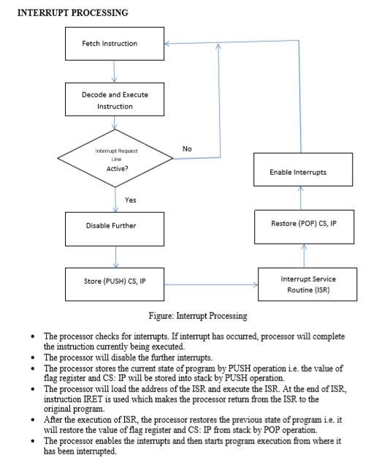

Interrupt hardware and priority
Vectored Interrupt
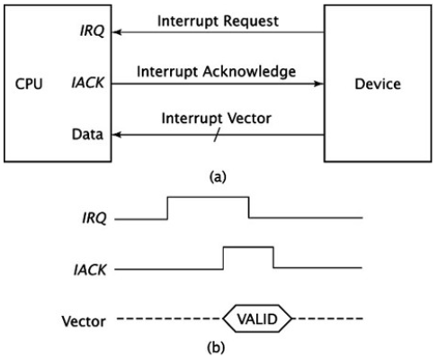
- CPU knows the address of ISR in advance.
- All it needs is that interrupting device sends its unique vector via a data bus and through its I/O interface to the CPU.
- CPU takes this vector, checks an interrupt table in memory and then carries correct ISR for the device.
Non-vectored interrupt
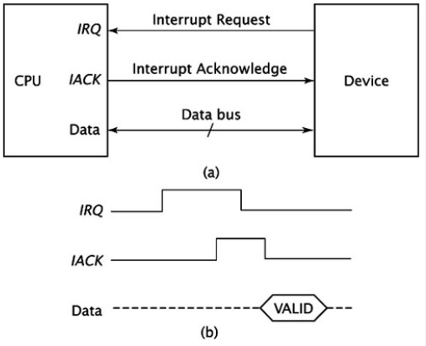
- Interrupting device never sends an interrupt vector.
- CPU receives the interrupt, and it jumps the program counter to a fixed address in hardware.
- CPU crucially does not know which device caused the interrupt without polling each I/O interface in a loop and checking status register of each I/O interface.
Prioritizing multiple interrupts:
Extension of non-vectored Interrupt
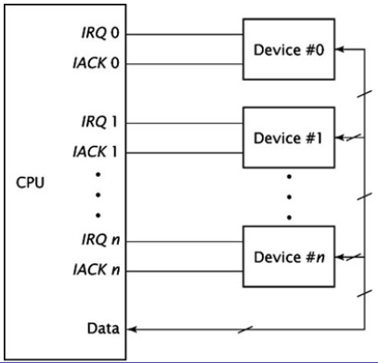
- IRQ_{n} has the highest priority and IRQ₀ has the lowest.
- If more than one device requests an interrupt, the CPU acknowledges and serves the interrupt with the highest priority first.
- This method works well when there are only a few IRQ/ACK pairs.
- As the number of interrupt increases, the number of pins needed by the CPU to accommodate these signals become prohibitive.

Daisy Chaining
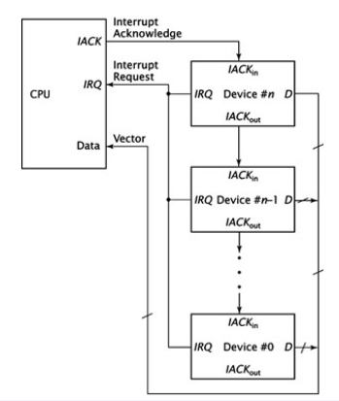
- The interrupt request signals from the devices are ORed together.
- When the CPU receives an active IRQ input, it doesn’t know which device generated the interrupt request.
- It sends out an acknowledgement signal and leaves it to the devices to work among themselves.
- Device #n receives the IACK signal directly from the CPU.
- If IACK is asserted, usually 1, this device has requested an interrupt; it sets its IACK_{out} signal to 0 and places its vector on the data bus.
- If this device did not request the interrupt, it sets its IACK_{out} signal to 1, thus passing it to device n-1 and so on until the IACK is asserted
- Straightforward and easy to implemented.
- The configuration is sequential, and thus can introduce hardware delays, if the chain is too long.

Implementing priority interrupts in parallel

- Implemented using priority encoder.
- Output of this encoder is the value of the highest priority device requesting an interrupt.
- Priority of the device doesn’t determine the time needed to acknowledge the interrupt.

